[Mehnaz Bano Roll No:23239555007]
Session: 2023 - 2025 | National college canal road
[Mobile Inventory System]
Software Requirements Specification Document
26.02.2026

Revision History
Date | Description | Author | Comments
01 Jan 26 | 1.0 | Mirza Nasir | Initial draft created including all major modules (Add Mobile, View Inventory, Update Mobile, Delete Mobile, Search Mobile, Customer Details, Sale/Transaction, Logout). Detailed functional and non-functional requirements added along with database design references.
15 Jan 26 | 1.1 | Mirza Nasir | Updated Use Cases with detailed field-level description for each module, added validation rules and error handling scenarios. Expanded database ERD description with all attributes.
05 Feb 26 | 1.2 | Mirza Nasir | Added Analysis Models section with sequence diagram descriptions, DFDs, and state transition flows. Expanded non-functional requirements with performance, reliability, and security metrics.
15 Feb 26 | 1.3 |  | Extended supporting information with background research and references for database normalization, inventory best practices, and UML modeling standards. Minor corrections to functional flows.
25 Feb 26 | 1.4 |  | Finalized document structure, added additional details to Customer and Sale/Transaction modules including field validations, calculations, and reporting procedures. Verified traceability of all requirements.

Document Approval
The following Software Requirements Specification has been accepted and approved by the following:
Signature | Printed Name | Title | Date
 | Mirza Nasir | Supervisor

Table of Contents
1. Introduction 4
1.1 Purpose 4
1.2 Scope 4
1.3 Definitions, Acronyms, and Abbreviations 4
1.4 References 5
1.5 Overview 5
2. The Overall Description 5
2.1 Product Perspective 5
2.2 Product Functions 6
2.3 User Characteristics 6
2.4 General Constraints 6
2.5 Assumptions and Dependencies 6
3. Specific Requirements 7
3.1 External Interface Requirements 7
3.2 Functional Requirements 7
3.3 Use Cases 8
3.4 Classes / Objects 15
3.7 Logical Database Requirements 18
3.5 Non-Functional Requirements 20
4. Analysis Models 20
5. Supporting Information 20

1. Introduction
The Mobile Inventory System (MIS) is a desktop-based application designed to manage mobile stock, customer information, and sales transactions efficiently. The system is intended to allow administrators to securely login, manage inventory, handle transactions, and generate reports through a user-friendly graphical interface.
This system aims to replace manual record-keeping, reduce errors, and provide faster access to inventory and sales data.

1.1 Purpose
The purpose of this SRS is to provide a comprehensive description of functional and non-functional requirements of the Mobile Inventory System.
Intended Audience:
- Developers: To design, implement, and maintain the system.
- Testers: To verify and validate the system functionality.
- Project Supervisors / Stakeholders: To review, approve, and track the project requirements.
- Future Enhancement Teams: For understanding the architecture and scaling the system.
This document ensures a single reference point for all system specifications, functional modules, database design, and operational requirements.

1.2 Scope
In Scope:
- Admin login/logout.
- Mobile inventory management (Add, Update, Delete, View, Search).
- Customer management (Add, Update, View purchase history).
- Sales / transaction recording and receipt generation.
- Inventory reporting and filtering options.
Out of Scope:
- Integration with accounting software.
- Web-based multi-user access (possible in future versions).
- Integration with mobile applications or external ERP systems.

1.3 Definitions, Acronyms, and Abbreviations
Term | Definition
DB | Database
IMEI | International Mobile Equipment Identity
UI | User Interface
SRS | Software Requirements Specification
CRUD | Create, Read, Update, Delete
MIS | Mobile Inventory System

1.4 References
- Microsoft SQL Server Documentation
- .NET Framework Documentation
- UML Standards (OMG, 2015)
- Desktop Application Security Best Practices
- Inventory Management System Design Guidelines

1.5 Overview
This document contains:
- General description of the system
- Detailed functional and non-functional requirements
- Use cases and class diagrams
- ERD and database design references
- Analysis models: Sequence diagrams, DFD, STD
- Supporting information including data dictionary

2. The Overall Description

2.1 Product Perspective
The system is standalone and does not depend on other software, but can be later integrated with accounting or reporting systems. It manages:
- Mobile inventory
- Customer records
- Sales transactions

2.1.1 Operations
- Admin login/logout
- CRUD operations for inventory
- Customer management
- Sale/transaction processing
- Search, filter, and reporting

2.1.2 Site Adaptation Requirements
- Runs on Windows OS with SQL Server installed
- Desktop-based environment

2.2 Product Functions
Function | Description
Admin Login | Secure access to the system
Add Mobile | Insert new mobile into inventory
View Inventory | Display all mobiles with filters
Update Mobile | Modify existing mobile details
Delete Mobile | Remove mobile from inventory
Search Mobile | Find specific mobile based on filters
Customer Details | Manage customer information
Sale / Transaction | Record sales, update inventory, generate receipts
Logout | Terminate admin session

2.3 User Characteristics
- Users: Admin only
- Education: Basic computer literacy
- Technical expertise: Familiarity with desktop software

2.4 General Constraints
- Hardware must support SQL Server
- Data must be secure
- System must handle up to 1000 records

2.5 Assumptions and Dependencies
- Admin credentials pre-registered
- Nightly backup available
- Windows OS installed

3. Specific Requirements

3.1 External Interface Requirements

3.1.1 System Interfaces
- SQL Server database
- Windows 10+
- Optional Excel for exporting reports

3.1.2 Interfaces
- GUI forms for inventory, sales, and customer management

3.1.3 Hardware Interfaces
- Desktop PC, keyboard, mouse
- Printer for receipts

3.1.4 Software Interfaces
- .NET Framework
- SQL Server 2019

3.1.5 Communications Interfaces
- LAN connectivity for future multi-user mode

3.2 Functional Requirements

3.2.1 Admin Login
- Inputs: Username, Password
- Processing: Validate against DB
- Outputs: Dashboard access or error message
- Error Handling: Invalid login alert

3.2.2 Add Mobile
- Inputs: Name, Brand, Model, RAM, Storage, Color, PurchasePrice, SalePrice, Quantity, IMEI, Image, Description
- Processing: Validate, check duplicates, insert DB
- Outputs: Updated inventory
- Error Handling: Missing fields, duplicate IMEI

3.2.3 View Inventory
- Display all mobile details with filters

3.2.4 Update Mobile
- Modify mobile details, validate, save

3.2.5 Delete Mobile
- Delete selected mobile after confirmation

3.2.6 Search Mobile
- Filter inventory by Name, Brand, Model, RAM, Storage

3.2.7 Customer Details
- Manage customer info: Name, Contact, Email, Address
- Add/Update customer records

3.2.8 Sale / Transaction
- Deduct sold quantity
- Record transaction with Customer & Mobile details
- Generate receipt

3.2.9 Logout
- Clear session and redirect to login

3.3 Use Cases

Use Case #1 – Admin Login
- Actor: Admin
- Preconditions: User exists
- Basic Flow: Enter credentials → Validate → Dashboard
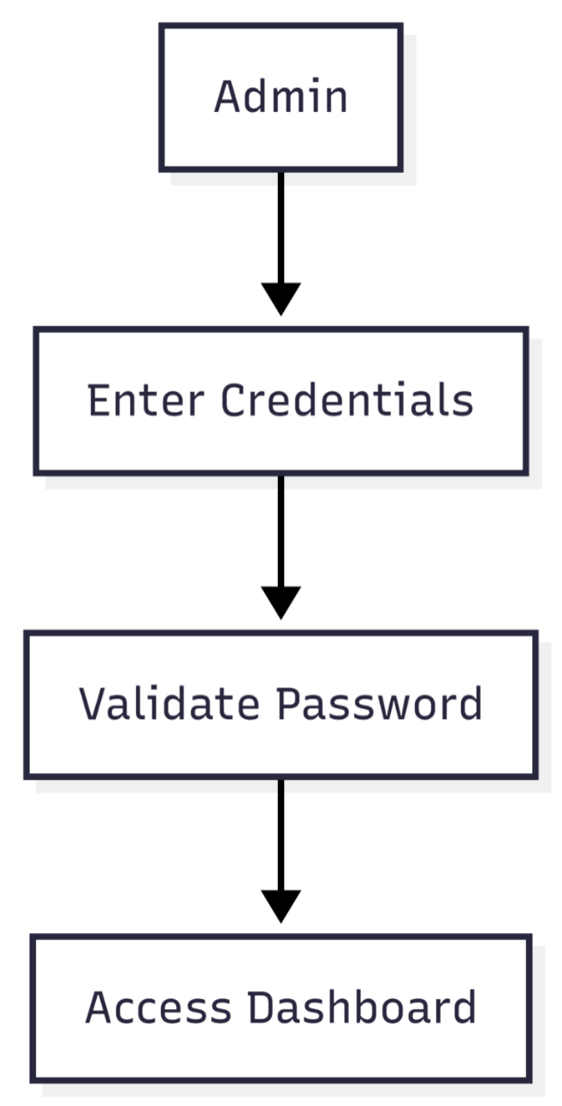

Use Case #2 – Add Mobile
- Actor: Admin
- Preconditions: Logged in
- Basic Flow: Enter details → Validate → Save
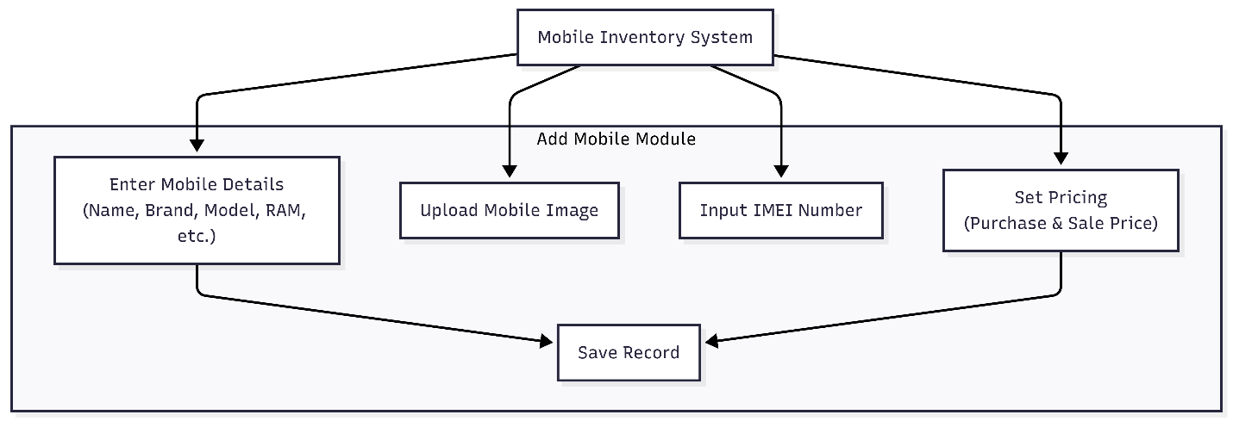

Use Case #3 – View Inventory
- Actor: Admin
- Preconditions: Logged in
- Basic Flow: Select inventory view → Filter → Display
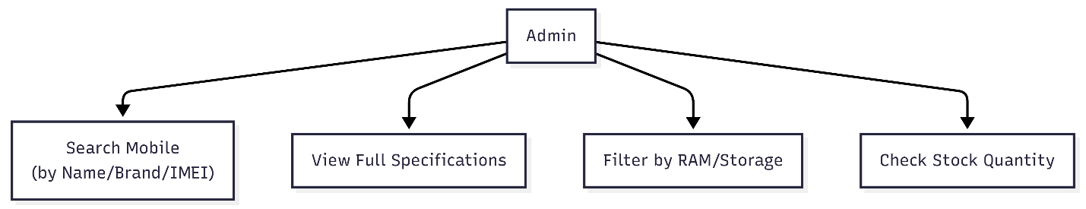

Use Case #4 – Update Mobile
- Actor: Admin
- Preconditions: Mobile exists
- Basic Flow: Select mobile → Edit → Save
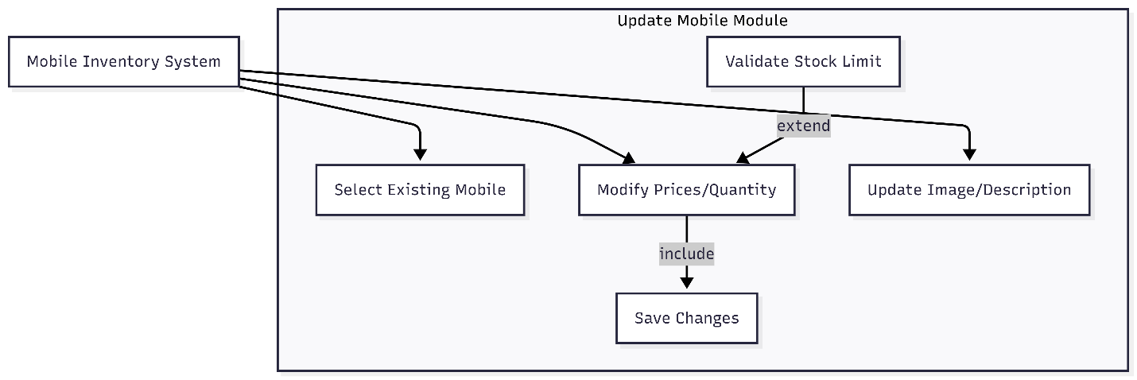

Use Case #5 – Delete Mobile
- Actor: Admin
- Preconditions: Mobile exists
- Basic Flow: Select mobile → Confirm → Delete
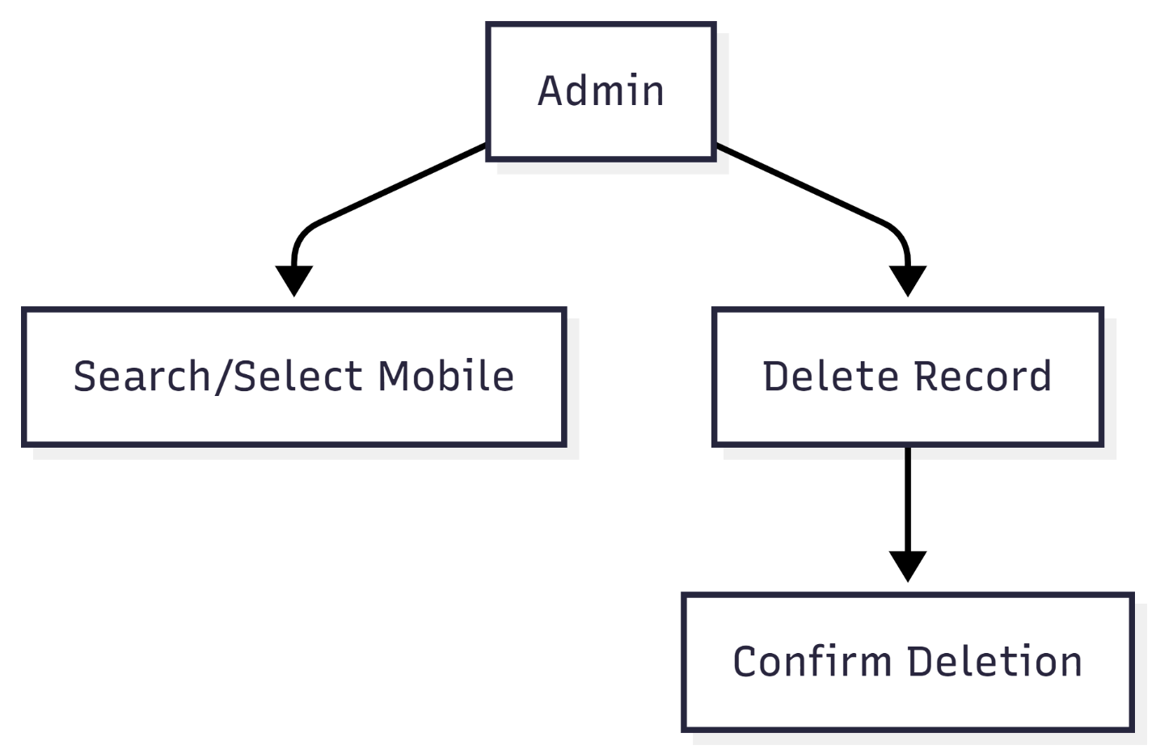

Use Case #6 – Search Mobile
- Actor: Admin
- Preconditions: Logged in
- Basic Flow: Enter search filters → Display results
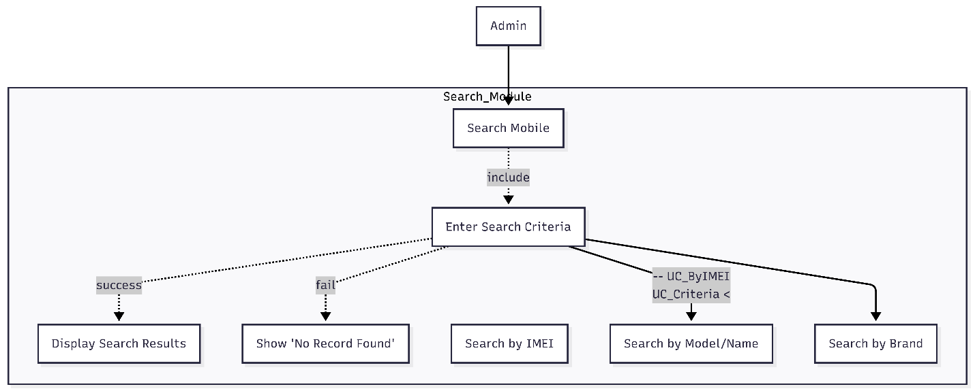

Use Case #7 – Customer Details
- Actor: Admin
- Preconditions: Logged in
- Basic Flow: Add/Update → Validate → Save
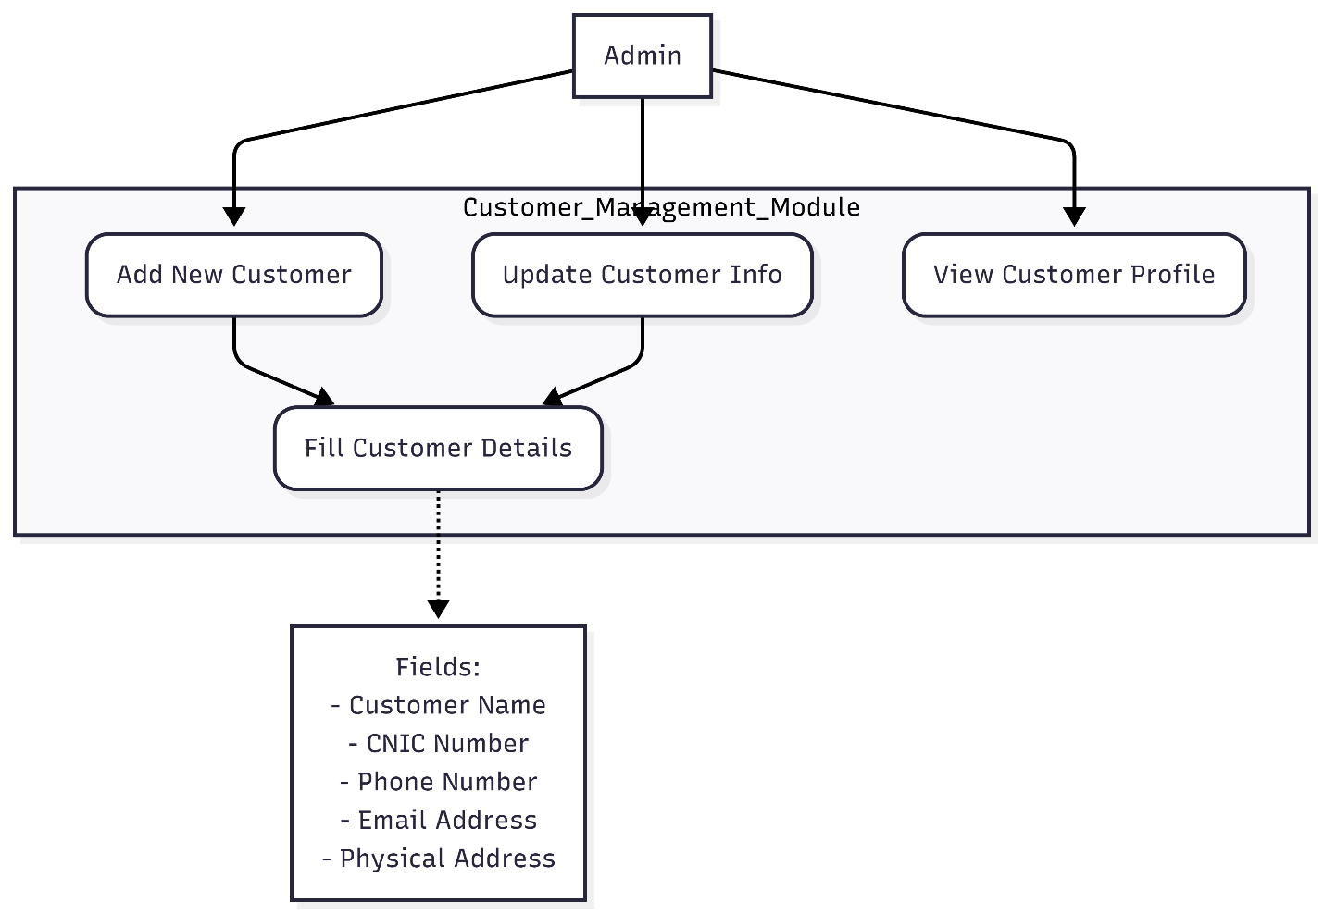

Use Case #8 – Sale / Transaction
- Actor: Admin
- Preconditions: Customer exists, mobile in stock
- Basic Flow: Select customer → Select mobile → Process sale → Receipt
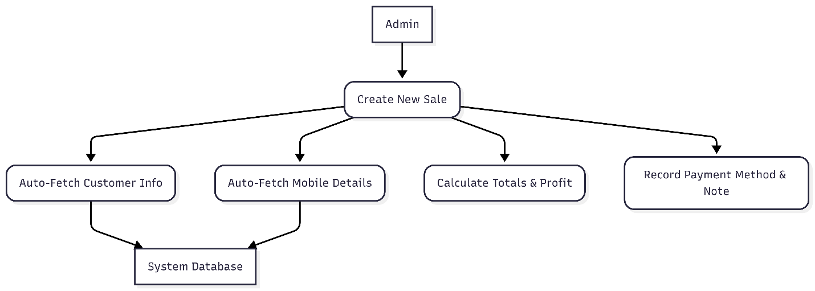

Use Case #9 – Logout
- Actor: Admin
- Preconditions: Logged in
- Basic Flow: Click logout → Session cleared → Login screen
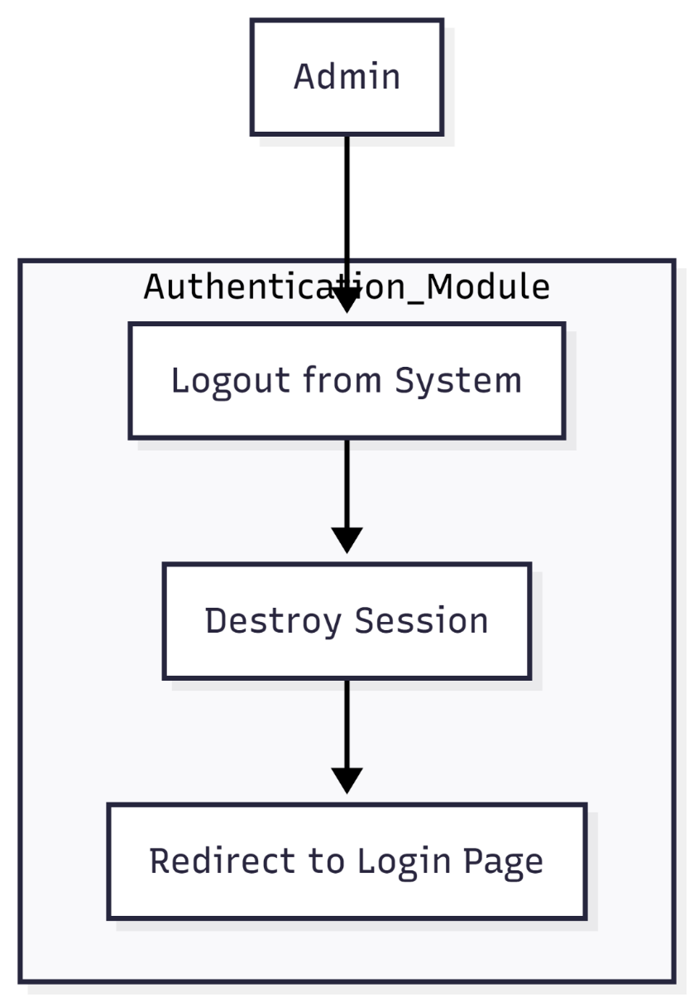

3.4 Classes / Objects

Mobile
Description: Represents a mobile device in the inventory.
Attributes:
- MobileID (int, Primary Key)
- Name (string, required)
- Brand (string, required)
- Model (string, required)
- RAM (string, optional)
- Storage (string, optional)
- Color (string, optional)
- PurchasePrice (decimal, required)
- SalePrice (decimal, required)
- Quantity (int, required)
- IMEI (string, unique, required)
- Image (blob, optional)
- Description (string, optional)
Functions / Methods:
- AddMobile() – Validate fields and insert into DB
- UpdateMobile() – Update mobile details in DB
- DeleteMobile() – Remove mobile record
- SearchMobile() – Return mobile records based on filters
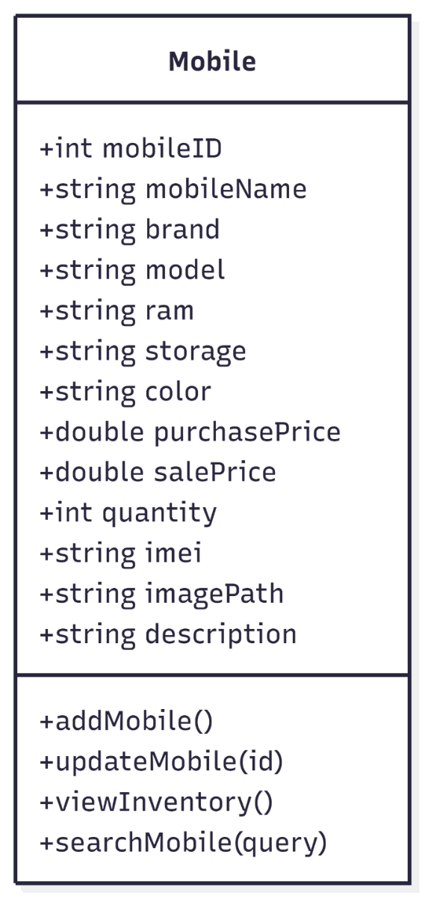

Customer
Description: Stores customer information and purchase history.
Attributes:
- CustomerID (int, Primary Key)
- Name (string, required)
- Contact (string, required)
- Email (string, optional)
- Address (string, optional)
• Functions / Methods:
- AddCustomer() – Insert new customer
- UpdateCustomer() – Modify existing details
- ViewPurchaseHistory() – Display past transactions

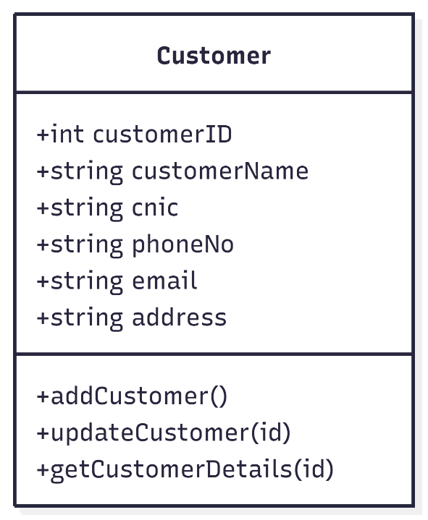

Transaction
Description: Represents a sales transaction.
Attributes:
- TransactionID (int, Primary Key)
- CustomerID (int, Foreign Key)
- MobileID (int, Foreign Key)
- Quantity (int, required)
- TotalPrice (decimal, required)
- Date (datetime, required)
Functions / Methods:
- RecordTransaction() – Deduct stock, save transaction, generate receipt
- ValidateStock() – Ensure mobile stock is sufficient before sale
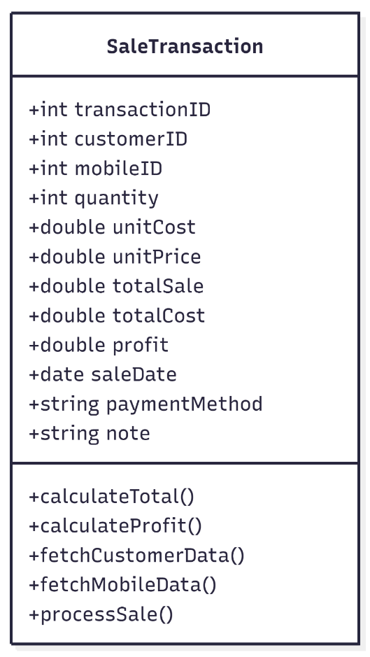

3.7 Logical Database Requirements
ERD Diagram
Tables and Relationships:

Mobile Table
Attribute | Type | Constraints
MobileID | INT | PK, Auto-increment
Name | VARCHAR | NOT NULL
Brand | VARCHAR | NOT NULL
Model | VARCHAR | NOT NULL
RAM | VARCHAR | NULL
Storage | VARCHAR | NULL
Color | VARCHAR | NULL
PurchasePrice | DECIMAL | NOT NULL
SalePrice | DECIMAL | NOT NULL
Quantity | INT | NOT NULL
IMEI | VARCHAR | UNIQUE, NOT NULL
Image | BLOB | NULL
Description | TEXT | NULL

Customer Table
Attribute | Type | Constraints
CustomerID | INT | PK, Auto-increment
Name | VARCHAR | NOT NULL
Contact | VARCHAR | NOT NULL
Email | VARCHAR | NULL
Address | TEXT | NULL

Transaction Table
Attribute | Type | Constraints
TransactionID | INT | PK, Auto-increment
CustomerID | INT | FK → Customer(CustomerID)
MobileID | INT | FK → Mobile(MobileID)
Quantity | INT | NOT NULL
TotalPrice | DECIMAL | NOT NULL
Date | DATETIME | NOT NULL

Relationships:
- Mobile → Transaction: One-to-Many
- Customer → Transaction: One-to-Many
ERD shows Mobile, Customer, Transaction tables with relationships and primary/foreign keys.
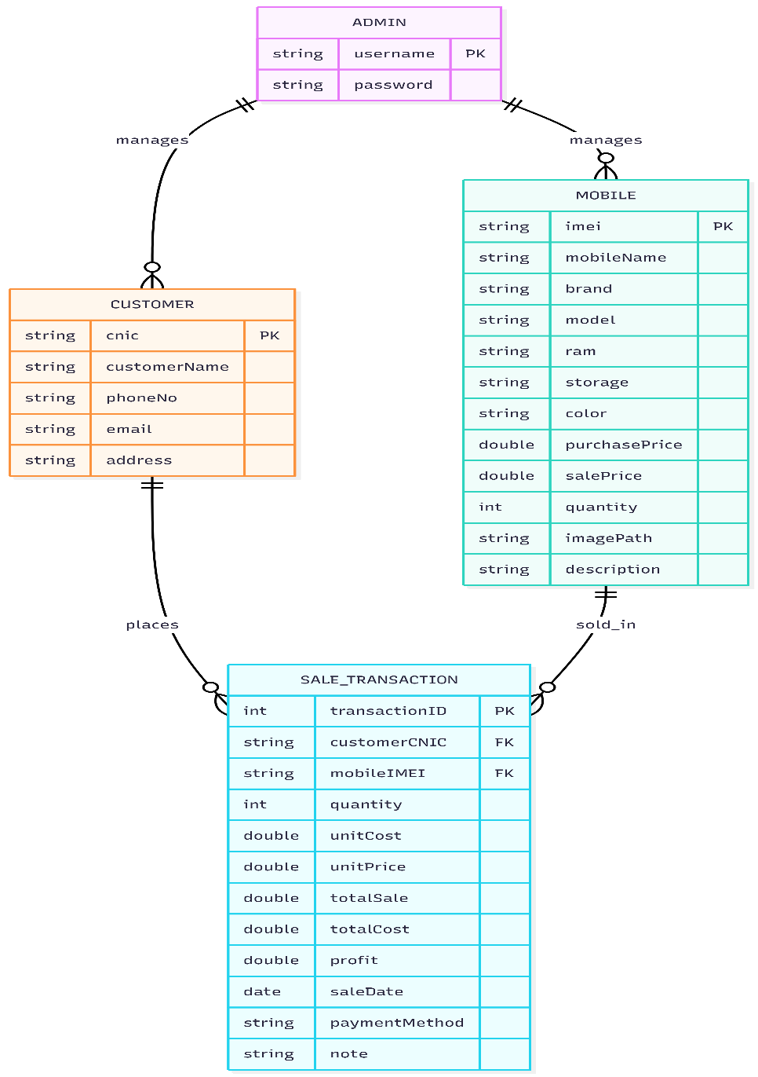

3.5 Non-Functional Requirements
Attribute | Requirement Detail
Performance | ≤1s response for ≤500 records in inventory; ≤2s for generating sales report
Reliability | Uptime ≥99.5%; automatic recovery from crashes
Availability | 24/7 system availability; scheduled maintenance notifications
Security | Role-based access; passwords hashed; database encrypted
Maintainability | Modular code; easy to add future modules (e.g., accounting integration)
Portability | Runs on Windows 10+; minimal hardware requirements
Backup | Nightly database backup; optional manual backup

4. Analysis Models
- Sequence diagrams for login, add mobile, sale transaction
- DFD Level 0 & 1
- State Transition diagrams for mobile status

5. Supporting Information

Appendix A – Background Research
- Best practices for inventory management
- Database normalization and indexing
- Security standards for desktop applications
- UML modeling standards (OMG 2015)

Appendix B – Data Dictionary
- Comprehensive field-level definitions included in Section 3.7 (Mobile, Customer, Transaction)

